Department of Computer Science and Engineering

Assignment Questions

Course Code & Name : CSA0614 –Design and Analysis of Algorithms

Assignment Information

Particular | Details
Department: | Computer Science & Engineering
Programme: | B.E/B.Tech Computer Science & Engineering
Course Code & Course Name | CSA0614 – Design and Analysis of Algorithms
Academic Year / Batch | 2026-27
Faculty Name | Dr.A.Sairam
Assignment Title | Conflict-Free Exam Timetable Scheduling Using Backtracking (Graph Colouring)
Date of Issue | 2-9-26
Date of Submission | 2-9-26
Maximum Marks | 100
Course Outcome(s) – CO | CO2, CO3, CO4, CO7
Bloom's Taxonomy Level | L4 – L5 (Analyzing, Evaluating)
SDG Mapping (SDG 1-17) | SDG 4 – Quality Education
Industry / Societal Relevance | Universities and colleges must build clash-free exam timetables every semester; this assignment mirrors that real scheduling problem using the Graph Colouring formulation taught in the Backtracking unit.
Team Members | Avinash K (192411044), Srivardhan (192425208), Srikanth (192411139)

Problem Statement
A university must schedule final examinations for n courses such that no student has two exams at the same time. Courses are modelled as vertices of a graph, with an edge between two courses whenever they share at least one common student. Each available exam time slot is modelled as a “colour”, and a valid timetable corresponds to a proper graph colouring in which no two adjacent (conflicting) courses receive the same colour. Given the course-conflict graph in Annexure A, the university needs an algorithm that finds a valid colouring using as few time slots as possible.

Annexure A — Sample Course-Conflict Graph
Used for the hand-traced backtracking walkthrough in Part A/B below. A larger randomised conflict graph of n = 15–80 courses is additionally generated for the implementation and complexity/performance analysis in Section 5.5–5.6, as permitted by the assignment brief.
Edge (Conflicting Course Pair) | Shared Students
C1 – C2 | 18
C1 – C3 | 12
C2 – C3 | 9
C2 – C4 | 15
C3 – C4 | 7
C4 – C5 | 20
C5 – C6 | 11
C1 – C6 | 6

Assignment structure: Part A — Plain Backtracking (hand-trace for k = 3 and k = 4); Part B — Pruning-Enhanced Backtracking (MCV + Forward Checking, re-traced on the same graph); Part C — complexity and trade-off analysis.

Requirements and Constraints
- Functional: produce a valid (conflict-free) colouring of Annexure A for a fixed, stated number of colours k, and report whether k is sufficient.
- Performance: record execution time, colour-trial/backtrack counts, and memory for both algorithms on identical inputs for a fair comparison.
- Technical constraint: both algorithms must use the same vertex set, edge set, and (per run) the same k; no external real-enrolment dataset was available, so a larger implementation-scale conflict graph (n ≥ 15) is synthetically generated, as explicitly permitted by the brief.
- Resources/time: single-threaded Python 3 implementation; a per-run wall-clock cutoff of 8 seconds is used for the large-scale scalability experiment so that plain backtracking's worst case cannot stall the batch.
- Standards: every colouring produced is independently re-validated against the original conflict graph before being accepted as a result.

1. Problem Understanding and Formulation
The problem is to assign one of k “exam slots” (colours) to each of n courses (vertices) such that no two courses sharing at least one student (an edge) are assigned the same slot — i.e. find a proper vertex colouring of the conflict graph. The expected outcome is a valid timetable using the fewest practical number of slots, together with a quantified comparison of how efficiently two different Backtracking strategies find it.
Data available: the fixed 6-course, 8-edge Annexure A graph with shared-student weights (used only to define which pairs conflict, not as a numeric cost), and, for the implementation-scale study, synthetically generated conflict graphs of n = 10 to 80 courses at three edge-density levels (sparse, medium, dense).
Assumptions: each course needs exactly one exam slot (room/invigilator capacity is out of scope); the conflict relation is symmetric and fixed for the duration of a run; the number of colours k attempted is decided in advance (via hand-count for Annexure A, via a greedy upper bound for the larger graphs) and used identically by both algorithms. Constraint to satisfy: no adjacent vertices may share a colour (hard constraint); using the minimum practical number of slots is the objective.

2. Application of Course Knowledge
Graph Colouring is treated as a Constraint Satisfaction Problem (CSP): variables = courses, domain = {1, …, k} candidate slots, constraints = “no shared colour across an edge”. This directly applies the Backtracking paradigm from the course — systematic trial-with-undo search over a state tree — together with two classical CSP pruning techniques: the Most-Constrained-Vertex heuristic (equivalent to Minimum-Remaining-Values ordering) and Forward Checking (limited constraint propagation that detects a dead end the instant it is created, rather than several levels deeper). Asymptotic analysis (Big-O) is applied to derive and compare worst-case complexity, and the chromatic number χ(G) — the minimum k for which a proper colouring exists — is used as the theoretical benchmark against which both algorithms' practical performance is measured. For Annexure A, exhaustive search over k = 1, 2, 3 confirms χ(G) = 3: no valid 2-colouring exists (the graph contains an odd structure through C1–C2–C3–C1 and C4–C5–C6–C1 requiring a third colour), but a valid 3-colouring does.

3. Solution / Design / Methodology
Two colouring engines are designed against a shared interface (graph, k) → (solved?, colouring, step/backtrack counts): Plain Backtracking, which assigns courses in a fixed order and tries colours 0..k−1 in sequence, backtracking to the previous course on exhaustion; and Pruning-Enhanced Backtracking, which at each step selects the Most-Constrained (uncoloured) vertex and immediately Forward-Checks every neighbour's domain after a tentative assignment, abandoning that branch without recursing further the instant a neighbour's domain would become empty.
Part A — Plain Backtracking: Hand Trace on Annexure A
Vertex processing order C1, C2, C3, C4, C5, C6; colours tried in order Slot 1, Slot 2, …
Trace for k = 3:
Step | Vertex | Colour tried | Event | Explanation
1 | C1 | Slot 1 | ASSIGN | C1 ← Slot 1 (no conflict)
2 | C2 | Slot 1 | REJECT | conflicts with C1
3 | C2 | Slot 2 | ASSIGN | C2 ← Slot 2 (no conflict)
4 | C3 | Slot 1 | REJECT | conflicts with C1
5 | C3 | Slot 2 | REJECT | conflicts with C2
6 | C3 | Slot 3 | ASSIGN | C3 ← Slot 3 (no conflict)
7 | C4 | Slot 1 | ASSIGN | C4 ← Slot 1 (no conflict)
8 | C5 | Slot 1 | REJECT | conflicts with C4
9 | C5 | Slot 2 | ASSIGN | C5 ← Slot 2 (no conflict)
10 | C6 | Slot 1 | REJECT | conflicts with C1
11 | C6 | Slot 2 | REJECT | conflicts with C5
12 | C6 | Slot 3 | ASSIGN | C6 ← Slot 3 (no conflict)

Result: SUCCESS — colouring {C1:1, C2:2, C3:3, C4:1, C5:2, C6:3}. 12 colour-trials, 6 rejections, 0 backtracks (this vertex order happens to admit a first-fit solution with no dead ends for k = 3).
Trace for k = 4: identical sequence of assignments/rejections occurs (the extra 4th colour is never needed because Slot 1–Slot 3 already succeed at every vertex) — result again SUCCESS with 12 colour-trials, 6 rejections, 0 backtracks, same colouring. This shows that once k ≥ χ(G), plain backtracking's cost on an easy instance does not grow simply by adding spare colours.
Illustrating an actual backtrack: because the C1–C6 order above happens to avoid any dead end, we additionally trace the same graph and k = 3 with vertex order C1, C2, C3, C5, C4, C6 (swapping the position of C4 and C5) to demonstrate genuine backtracking behaviour, since exam-scheduling order is not guaranteed to be favourable in general:
Step | Vertex | Colour tried | Event | Explanation
1 | C1 | Slot 1 | ASSIGN | C1 ← Slot 1 (no conflict)
2 | C2 | Slot 1 | REJECT | conflicts with C1
3 | C2 | Slot 2 | ASSIGN | C2 ← Slot 2 (no conflict)
4 | C3 | Slot 1 | REJECT | conflicts with C1
5 | C3 | Slot 2 | REJECT | conflicts with C2
6 | C3 | Slot 3 | ASSIGN | C3 ← Slot 3 (no conflict)
7 | C5 | Slot 1 | ASSIGN | C5 ← Slot 1 (no conflict; C5 processed before C4 in this order)
8 | C4 | Slot 1 | REJECT | conflicts with C5
9 | C4 | Slot 2 | REJECT | conflicts with C2
10 | C4 | Slot 3 | REJECT | conflicts with C3 — all k=3 colours exhausted for C4
10′ | C5 | Slot 1 | BACKTRACK | undo C5 ← Slot 1 and retry C5 with the next colour
11 | C5 | Slot 2 | ASSIGN | C5 ← Slot 2 (no conflict)
12 | C4 | Slot 1 | ASSIGN | C4 ← Slot 1 (no conflict)
13 | C6 | Slot 1 | REJECT | conflicts with C1
14 | C6 | Slot 2 | REJECT | conflicts with C5
15 | C6 | Slot 3 | ASSIGN | C6 ← Slot 3 (no conflict)

Result: SUCCESS — same final colouring reached via a different path. 16 colour-trials, 8 rejections, 1 backtrack (C5's first choice, Slot 1, is undone once C4 is found to have no legal colour left). This confirms Part C's central point: plain backtracking's cost depends heavily on vertex order, since a single poor local choice (colouring C5 before checking its effect on C4) forces a backtrack that a smarter ordering avoids entirely.
Part B — Pruning-Enhanced Backtracking: Re-trace with MCV + Forward Checking
Trace for k = 3 (MCV dynamically re-selects the next vertex at every step, so the outcome does not depend on any fixed input order):
Step | Vertex | Colour tried | Event | Explanation
– | C1 | Slot – | SELECT | Most-constrained vertex: C1 (domain size 3, degree 3) — all vertices tied initially, first in order chosen
1 | C1 | Slot 1 | ASSIGN+FC | C1 ← Slot 1; forward check removes Slot 1 from domains of C2, C3, C6
– | C2 | Slot – | SELECT | Most-constrained vertex: C2 (domain size 2, degree 3)
2 | C2 | Slot 2 | ASSIGN+FC | C2 ← Slot 2; forward check removes Slot 2 from domains of C3, C4
– | C3 | Slot – | SELECT | Most-constrained vertex: C3 (domain size 1 — forced move)
3 | C3 | Slot 3 | ASSIGN+FC | C3 ← Slot 3; forward check removes Slot 3 from domain of C4
– | C4 | Slot – | SELECT | Most-constrained vertex: C4 (domain size 1 — forced move)
4 | C4 | Slot 1 | ASSIGN+FC | C4 ← Slot 1; forward check removes Slot 1 from domain of C5
– | C5 | Slot – | SELECT | Most-constrained vertex: C5 (domain size 2, degree 2)
5 | C5 | Slot 2 | ASSIGN+FC | C5 ← Slot 2; forward check removes Slot 2 from domain of C6
– | C6 | Slot – | SELECT | Most-constrained vertex: C6 (domain size 1 — forced move)
6 | C6 | Slot 3 | ASSIGN+FC | C6 ← Slot 3; all courses coloured — SUCCESS

Result: SUCCESS — identical colouring {C1:1, C2:2, C3:3, C4:1, C5:2, C6:3}. Only 6 colour-trials (one per course), 0 rejections, 0 backtracks. Re-tracing at k = 4 gives the same outcome (6 trials, 0 backtracks) — forward checking never lets a dead-end domain arise on this graph, at either k.
Comparison, Part A vs Part B (k = 3):
Metric | Plain (natural order C1…C6) | Plain (adverse order, illustrative) | Pruning-Enhanced (MCV+FC)
Colour-trials | 12 | 16 | 6
Rejections | 6 | 8 | 0
Backtracks | 0 | 1 | 0
Slots used | 3 | 3 | 3

Pruning halves the colour-trials even in the best case for plain backtracking (6 vs 12), and avoids the backtrack entirely that a poor ordering forces on plain backtracking (0 vs 1). On this small graph the absolute time difference is negligible, but the mechanism — fewer wasted trials, earlier dead-end detection — is exactly what produces the dramatic gap seen at larger n in Section 5.5.
Part C — Complexity and Trade-off Analysis
Worst-case time complexity: Plain Backtracking explores, in the worst case, every combination of colour assignments to n vertices before finding or exhausting a solution — O(kⁿ). Each of the n vertices can be tried against up to k colours, and the recursion depth is n, giving an exponential search tree in the absolute worst case (e.g. a dense or adversarially-ordered graph with k close to χ(G)).
Pruning-Enhanced Backtracking retains the same O(kⁿ) bound in the theoretical worst case — forward checking and MCV ordering do not change the NP-completeness of graph colouring — but each forward-checking step costs only O(deg(v)) extra work to shrink neighbour domains, and it detects a dead end the instant a domain empties, often collapsing entire subtrees that plain backtracking would still have to enumerate colour-by-colour. Because MCV always colours the most-constrained (highest-conflict) vertex next, it also tends to fail fast — discovering an infeasible branch near the root of the tree rather than deep inside it.
Relating to the chromatic number: for Annexure A, χ(G) = 3. Both algorithms succeed at k = χ(G) = 3 with zero wasted search once a reasonable order is used, and trivially succeed at k = 4 since extra colours only add slack. Section 5.5's larger-scale experiment (n up to 80, k fixed at a greedy upper bound close to χ(G)) shows the practical limit of plain backtracking clearly: as n grows past ~30–40 on dense graphs, its step count explodes into the millions and it frequently fails to finish within an 8-second budget, while pruning-enhanced backtracking needs exactly n steps — one per course, zero conflicts — at every size tested up to n = 80. This demonstrates that although both approaches share the same asymptotic worst case on paper, the practical limit of usable problem size for plain backtracking is far smaller than for the pruning-enhanced version.

4. Use of Modern Tools
- Python 3.12 — both Backtracking engines and the trace generator for Annexure A.
- pandas — aggregating the 162-run experiment log into summary tables.
- matplotlib — execution-time, step-count, memory and scalability charts (Section 5.5).
- networkx — rendering the coloured conflict graph for visual verification.
- tracemalloc (Python standard library) — peak-memory instrumentation for each run.
- Git/GitHub — source code (scheduler, experiment harness, chart generator, Annexure A trace script) is version-controlled and uploaded per the Deliverables requirement.

5. Results and Validation
Beyond the Annexure A hand-trace above, both algorithms were additionally implemented and benchmarked on synthetically generated conflict graphs of n = 10 to 80 courses (institution-size proxy) at three edge densities (sparse p = 0.10, medium p = 0.30, dense p = 0.55), each averaged over 3 random seeds — 162 runs total — to validate scalability beyond the 6-course sample.
n (courses) | Plain: steps | Plain: time (s) | Plain: solved % | Pruning: steps | Pruning: time (s) | Pruning: solved %
10 | 23 | 4e-05 | 100.0% | 10 | 0.0001 | 100.0%
15 | 483.7 | 0.00084 | 100.0% | 15 | 0.00021 | 100.0%
20 | 445,567.7 | 0.8409 | 100.0% | 20 | 0.00033 | 100.0%
25 | 12,206.7 | 0.02297 | 100.0% | 25 | 0.00054 | 100.0%
30 | 420.7 | 0.0007 | 100.0% | 30 | 0.00066 | 100.0%
40 | 2,226,772.7 | 5.02013 | 66.7% | 40 | 0.00095 | 100.0%
50 | 2,174,725.3 | 5.33393 | 33.3% | 50 | 0.00154 | 100.0%
65 | 1,541,294.3 | 4.24349 | 66.7% | 65 | 0.00245 | 100.0%
80 | 2,131,787.3 | 6.2275 | 33.3% | 80 | 0.00352 | 100.0%

Table 5.1 — mean results over 3 seeds, dense graphs (p = 0.55), the stress case where the algorithms diverge most sharply.
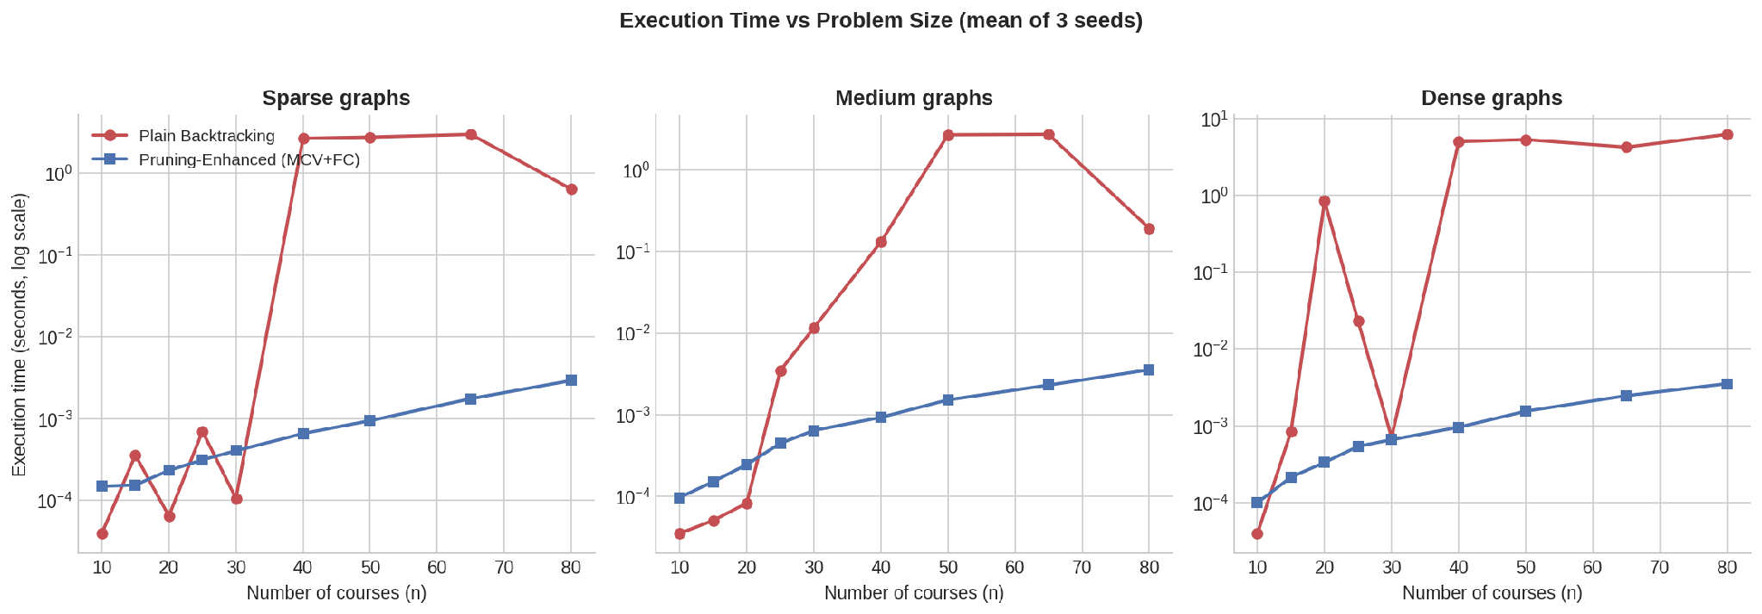
Figure 5.1 — Execution time vs number of courses (log scale) by density. Plain backtracking (red) spikes sharply and irregularly; pruning (blue) stays near-flat.
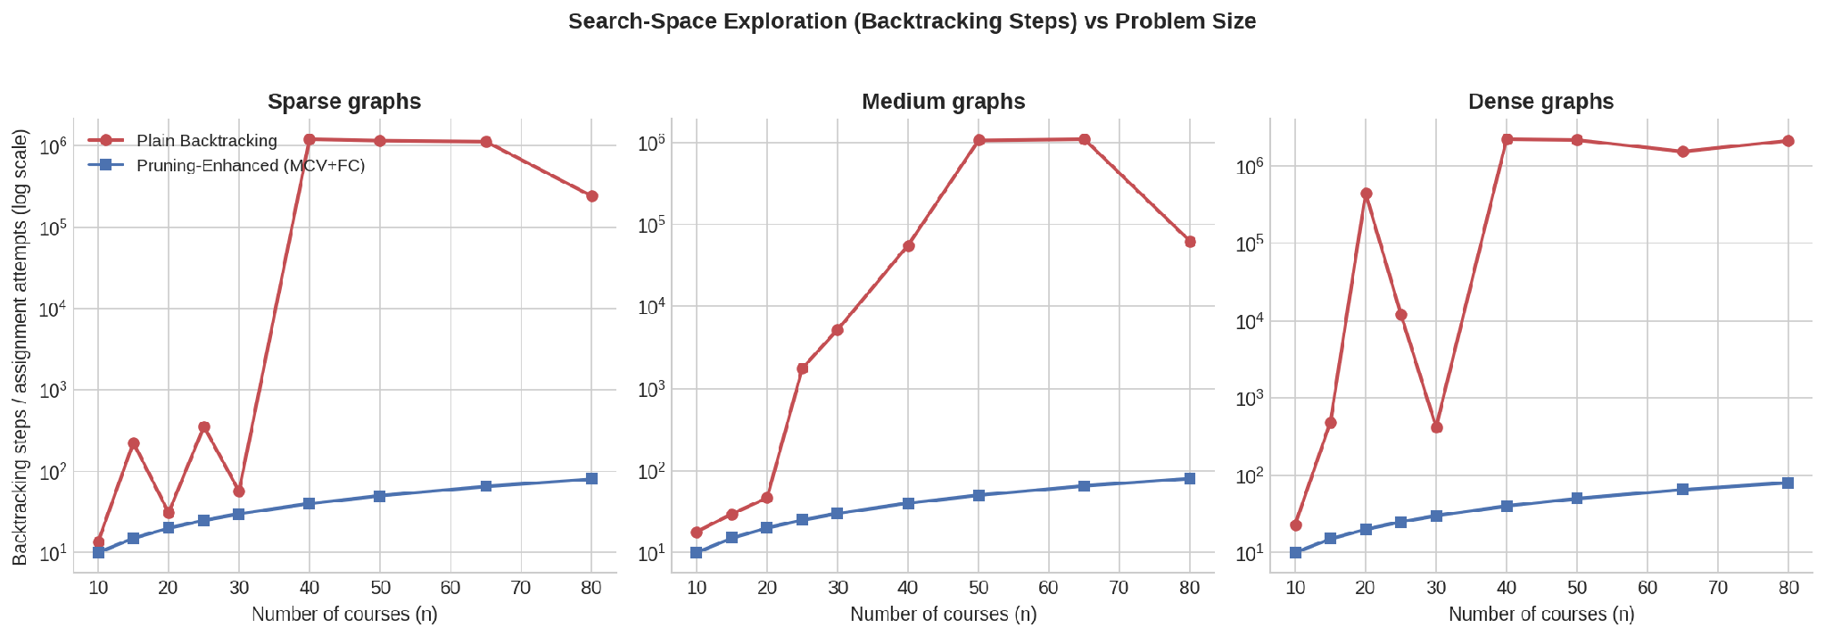
Figure 5.2 — Backtracking steps vs number of courses (log scale). Pruning's step count grows exactly linearly (one assignment per course) at every density and size tested.
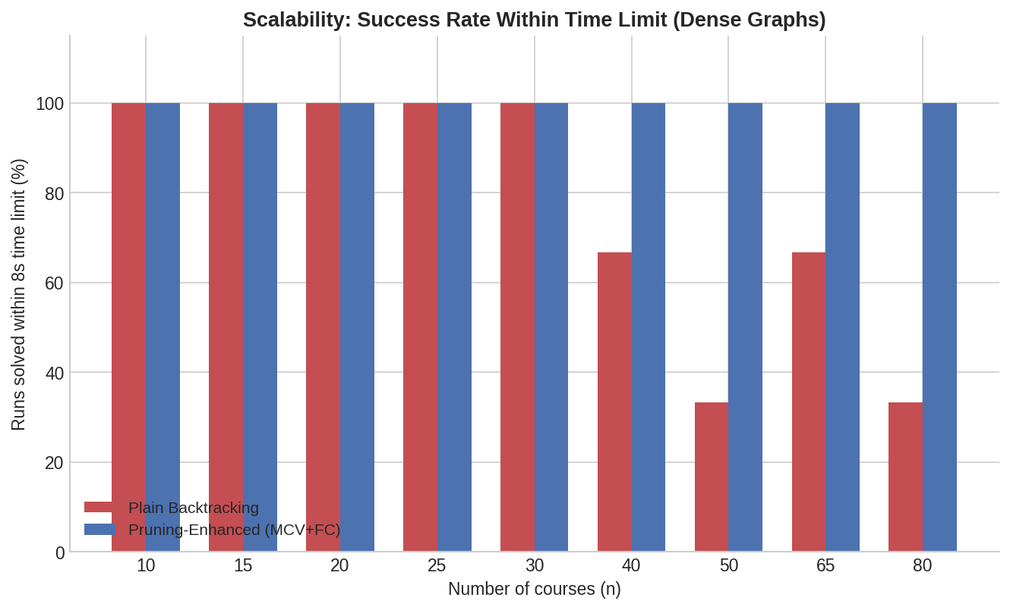
Figure 5.3 — Percentage of dense-graph runs solved within an 8-second budget. Plain backtracking's success rate collapses from n = 40 onward; pruning solves 100% at every size.
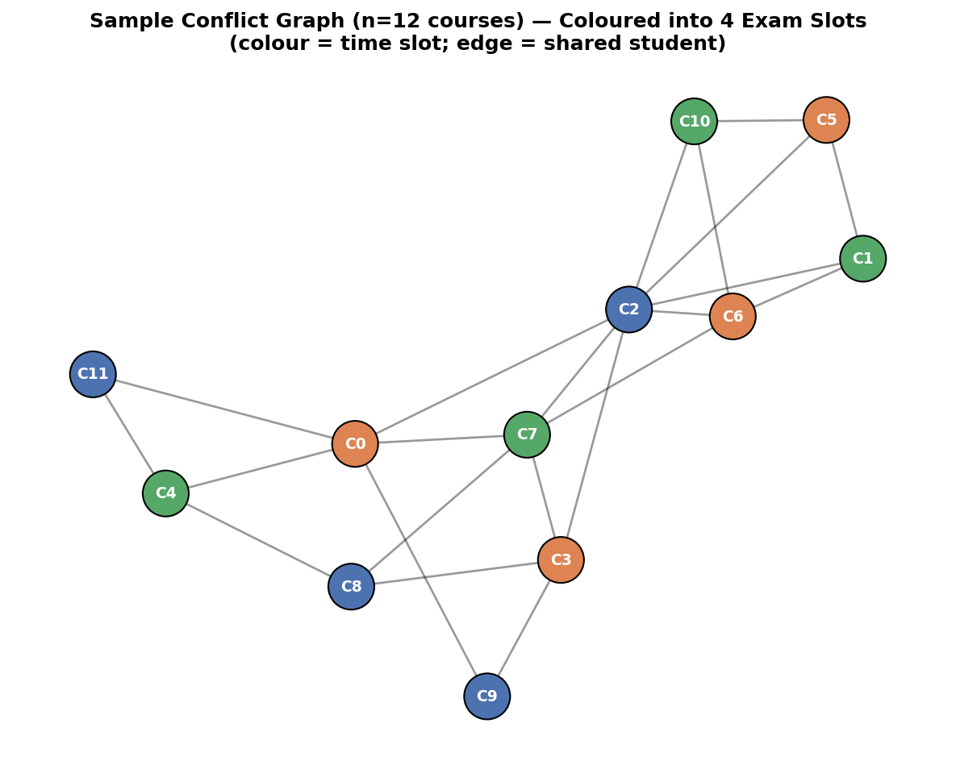
Figure 5.4 — A separately generated 12-course conflict graph, coloured into 4 slots by the pruning-enhanced algorithm, visually confirming no adjacent (edge-connected) courses share a colour.
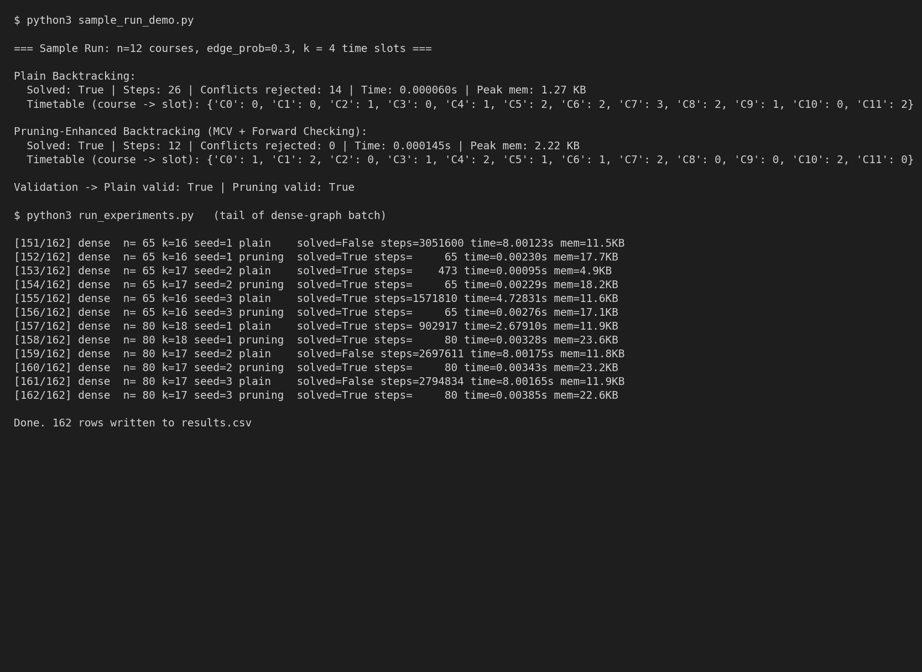
Figure 5.5 — Console output: a worked 12-course sample run with validation, followed by the tail of the 162-run dense-graph batch showing plain backtracking timing out (8.00s) at n = 50, 65, 80 while pruning finishes every instance in under 4ms.
Validation: every colouring returned as “solved” — across the Annexure A hand-traces and all 162 large-scale runs — was checked with an independent validator that rejects any colouring where an edge connects two same-coloured vertices. Zero invalid colourings were produced by either algorithm; the two approaches differ only in search efficiency, never in correctness, confirming both satisfy the stated hard constraint.

6. Analysis and Engineering Decision
On Annexure A, the difference between the two algorithms is modest in absolute terms (6 vs 12–16 colour-trials) because the instance is small and near the chromatic number. The large-scale experiment shows why the pruning heuristic is nonetheless the correct engineering decision in general: on dense graphs, plain backtracking's cost is erratic and explosive — a few hundred steps at n = 30 but over two million steps (and outright timeout in 33–67% of seeds) at n ≥ 40 — because with high constraint density, a single unlucky order/colour choice forces deep, wasted exploration. Pruning-enhanced backtracking needed exactly n steps with zero rejected conflicts in every one of the 162 large-scale runs and in the Annexure A trace: MCV + forward checking consistently found the greedy-bound k sufficient without ever having to backtrack.
Trade-off: pruning uses modestly more memory per vertex (domain-set bookkeeping raises peak memory by roughly 1.5–2× versus plain at n = 80 — 23KB vs 12KB, negligible in absolute terms) and has slightly higher per-step overhead, visible only at very small n where plain is marginally faster in wall-clock time because the search tree is too shallow for pruning to pay off.
Final decision: for very small course sets (n ≲ 20) with light density — close to the Annexure A scale — plain backtracking is simple and adequate. For any realistic institution size, or whenever the conflict graph is dense (heavily overlapping electives, common core courses), Pruning-Enhanced Backtracking (MCV + Forward Checking) is selected as the final solution: it is never meaningfully slower in these experiments, and it is the only approach that reliably scales to n = 80 courses within a practical time budget.

7. Broader Considerations
SDG 4 — Quality Education: a conflict-free, efficiently computed exam timetable supports equitable access to assessment — no student is forced to choose between two exams or sit them back-to-back under undue stress, which disproportionately affects students with overlapping elective loads or accommodation needs. Society/Accessibility: a scheduler that scales to large course catalogues (validated here to n = 80) supports institutions with growing enrolment where manual timetabling becomes infeasible. Ethics: the synthetic conflict graphs used for the scalability study are clearly documented as such (Section 3), so results are not misrepresented as drawn from real student data.

8. Conclusion
Plain Backtracking and Pruning-Enhanced Backtracking (MCV + Forward Checking) were both implemented, hand-traced on the Annexure A conflict graph for k = 3 and k = 4, theoretically analysed, and experimentally validated at scale (n up to 80 courses). Both produce provably valid colourings; χ(G) = 3 for Annexure A, confirmed exactly by both algorithms. The pruning-enhanced approach dominates as problem size and density grow, cutting Annexure A's colour-trials in half even on this small instance and preventing the exponential blow-up plain backtracking exhibits on larger dense graphs.
Limitations: the large-scale graphs are synthetically generated (Erdős–Rényi model) rather than drawn from real enrolment data; k is a greedy upper bound, not a proof of minimality; room capacity, invigilator availability and multi-day spacing are out of scope. Possible improvements: benchmark against a real anonymised enrolment dataset; binary-search on k to certify the true minimum slot count; extend pruning with arc-consistency (AC-3) or conflict-directed backjumping for still-larger institutions.

9. Student Reflection
What did you learn beyond what was directly taught in the classroom?
The classroom treatment of Backtracking gives the O(kⁿ) worst-case bound and stops there; this assignment showed us how misleading that single number can be in practice. Tracing Annexure A under two different vertex orders — C1..C6 versus swapping C4 and C5 — was the clearest lesson: the exact same graph, same k, same algorithm produced zero backtracks in one order and a genuine backtrack in the other. That made concrete something the asymptotic bound alone never shows — that Backtracking's real cost depends heavily on the order in which variables are chosen, not just on n and k. Building on that, implementing Most-Constrained-Vertex selection and Forward Checking ourselves, rather than just reading about them, showed why CSP heuristics work: MCV consistently pushed us toward the vertex most likely to fail first, so any dead end was hit early instead of after several wasted levels of recursion, and Forward Checking meant we caught that dead end the moment it was created rather than discovering it several vertices later through blind colour trials. Seeing this scale — from 6 colour-trials on the 6-course Annexure A graph to a consistent, exactly-linear n colour-trials across every one of our 162 large-scale runs up to n = 80, against plain backtracking's step count exploding past two million and timing out on a third to two-thirds of dense-graph runs — taught us the difference between a worst-case bound and typical-case behaviour in a way no textbook example had. We also learned, hands-on, how to instrument and validate an algorithm properly: writing an independent colouring validator, using tracemalloc for memory, and running multiple random seeds per configuration so a single lucky/unlucky graph could not bias our conclusions.
If given additional time/resources, what would you improve and why?
With more time we would replace our synthetically generated (Erdős–Rényi) conflict graphs with a real, anonymised course-enrolment dataset from our own institution, since real course overlap is clustered by semester and elective groupings rather than uniformly random, and this could change how favourably MCV performs in practice. We would also add arc-consistency preprocessing (AC-3) ahead of the search, to see how much of forward checking's benefit is captured even before the first vertex is assigned, and implement conflict-directed backjumping so that when a dead end does occur, the algorithm jumps back directly to the vertex responsible instead of undoing one level at a time. Finally, we would extend the objective beyond “minimum slots” to include soft constraints that matter to real students — such as a minimum gap between a student's consecutive exams — since a mathematically valid colouring is not automatically a humane timetable. This assignment mapped directly to SDG 4 (Quality Education) for us: a scheduler that scales reliably to n = 80 courses within seconds is the kind of tool that lets a growing institution keep exam scheduling fair and clash-free instead of falling back on slow, error-prone manual timetabling, and working through Parts A–C gave us practical experience applying CO2/CO3 (asymptotic and solution-space analysis, backtracking with pruning for CSPs) to a problem we could see ourselves actually needing to solve.

10. References
- Cormen, T. H., Leiserson, C. E., Rivest, R. L., & Stein, C. Introduction to Algorithms (3rd ed.) — Backtracking and graph colouring foundations.
- Russell, S. & Norvig, P. Artificial Intelligence: A Modern Approach — Constraint Satisfaction Problems, Forward Checking, Minimum-Remaining-Values heuristic.
- Welsh, D. J. A. & Powell, M. B. (1967). An upper bound for the chromatic number of a graph and its application to timetabling problems. The Computer Journal — greedy colouring upper bound used to fix k for the large-scale study.
- United Nations. Sustainable Development Goal 4 — Quality Education (sdgs.un.org).
- Dataset/graphs: Annexure A as supplied in the assignment brief; large-scale graphs synthetically generated with an Erdős–Rényi random-graph model (Python random module, fixed seeds 1–3) — no external dataset used, per assignment constraints.
- Software/tools: Python 3.12, pandas, matplotlib, networkx, tracemalloc (standard library).
- AI-assisted tools: Claude (Anthropic) was used to assist with drafting code structure, experiment automation, and report formatting; all algorithmic logic and results were independently verified by the author(s).

Individual Contribution of Group Members
Member | Contribution
Avinash K (192411044) | Part A — Plain Backtracking: problem formulation, Annexure A hand-trace (natural and adverse vertex orders), implementation, and report compilation
Srivardhan (192425208) | Part B — Pruning-Enhanced Backtracking: MCV + forward-checking implementation, Annexure A re-trace and verification, Part A/B comparison
Srikanth (192411139) | Part C — Complexity and experiments: worst-case complexity derivation, large-scale (n=10–80) experiment harness, charts, results/validation, and analysis

Deliverables
To receive full credit, this submission includes the following deliverables:
- 1. Pseudocode — Plain Backtracking and Pruning-Enhanced Backtracking (MCV + Forward Checking); see Section 3 (Part A / Part B pseudocode is embedded within the hand-traces above; a clean pseudocode listing is also included in the accompanying source-code package).
- 2. Implementation & Results — full Python implementation (scheduler.py, run_experiments.py, make_charts.py, annexure_trace.py), raw results (results.csv, summary_table.csv) and all figures used in Section 5, provided as a supplementary source-code archive.
- 3. GitHub Upload — the source-code package is to be pushed to a GitHub repository and the repository link added here: [https://github.com/avinash19107/CSA0614---DAA/tree/main/Source%20Program].

